I recommend a different project that still covers your syllabus but is more unique and practical.

Project: AI-Powered Fake News Detection and Intelligent News Retrieval System
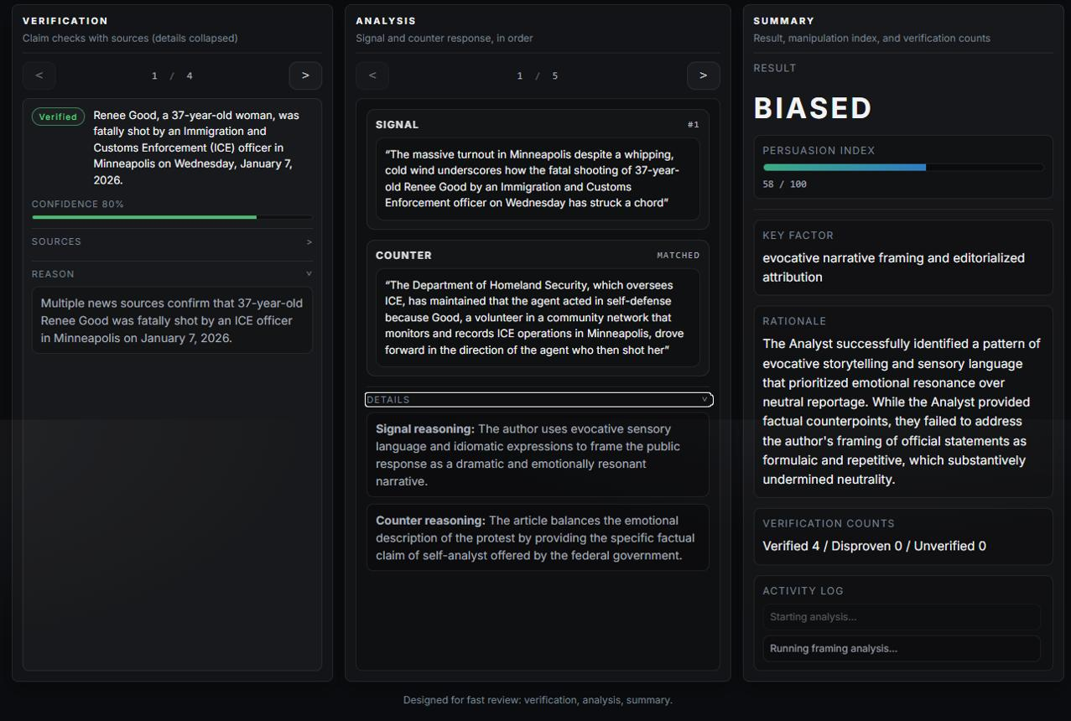
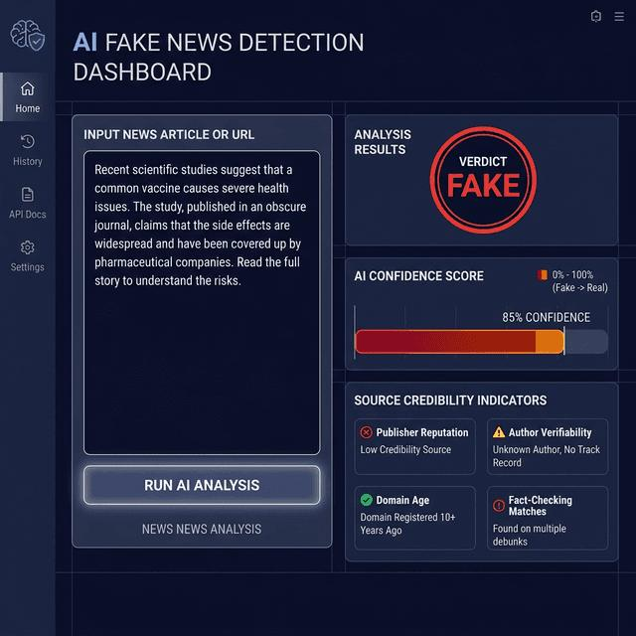
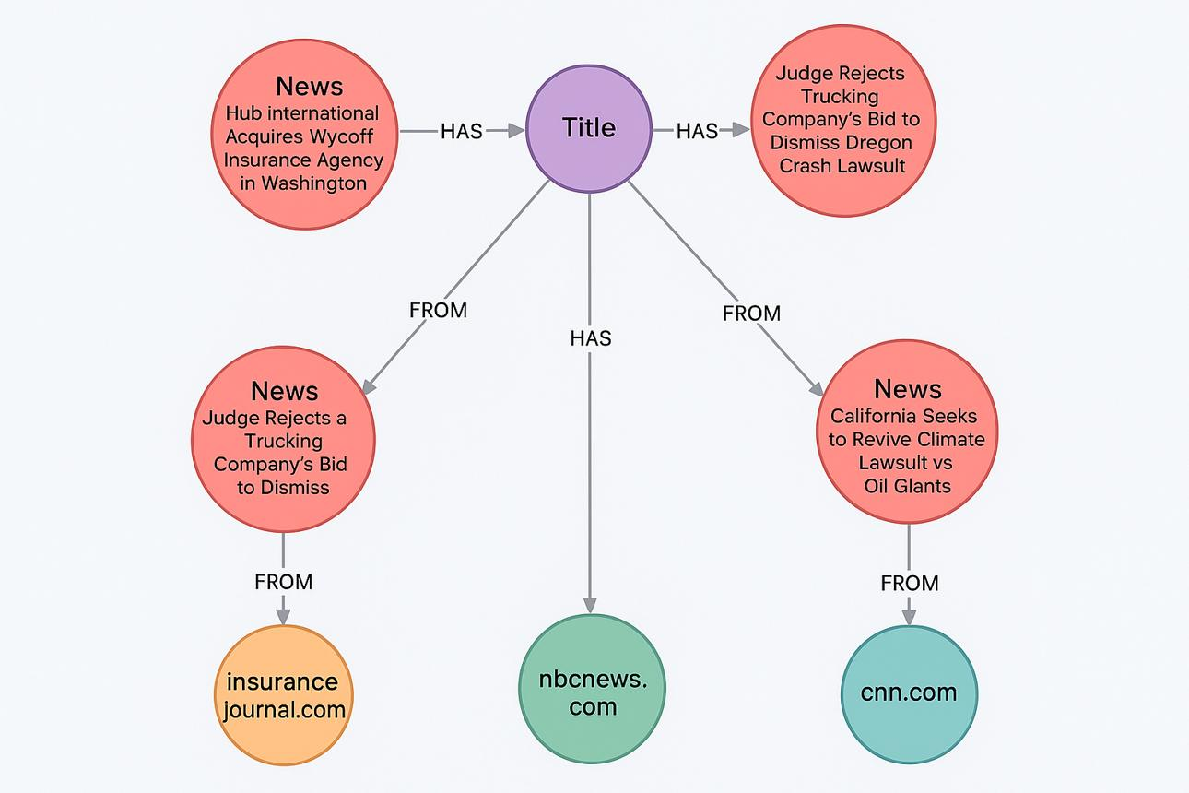
12
Project idea: Build a system that collects news articles, detects potentially misleading or fake news, groups related stories, ranks credible and relevant articles, and allows users to explore news through an AI-powered search interface.
For example, a user searches for "latest news about electric vehicle battery fires". The system retrieves related articles, groups duplicate stories, ranks relevant results, and displays a credibility prediction for each article.

How it covers your syllabus
Syllabus topic | Implementation in the project
Word embeddings | Identify articles with similar meanings
Clustering-based retrieval | Group articles covering the same event
Topic modeling | Discover topics such as politics, health, and technology
Dimensionality reduction | Visualize article clusters using PCA or t-SNE
Anomaly detection | Flag unusual article patterns for review
Classification-based retrieval | Classify articles into news categories
Learning to Rank | Rank search results by relevance and other features
Neural networks and BERT | Classify article text and rerank search results
Feature engineering | Use source, headline, writing style, and text features
Ensemble methods | Combine predictions from multiple classifiers
Neural Information Retrieval | Retrieve articles using semantic embeddings
Multimodal retrieval | Search news using text and associated images
CLIP | Match text queries with news images
Chatbot-based search | Ask questions about retrieved articles
Real-time and streaming IR | Index newly collected articles continuously

Technology stack
- Language: Python
- Frontend: Streamlit
- Machine learning: Scikit-learn
- NLP and deep learning: Hugging Face Transformers, BERT
- Semantic search: Sentence Transformers and FAISS
- Image retrieval: CLIP
- Database: SQLite or MongoDB
- News data: Public news datasets, such as FakeNewsNet, subject to dataset access and licensing

Main modules
- News collection and preprocessing.
- Fake-news classification with a confidence score.
- Semantic search and relevance ranking.
- Duplicate-news detection and topic clustering.
- Text-to-image news retrieval.
- Conversational news exploration.
- Evaluation dashboard showing classification metrics and retrieval performance.
Important: The system should flag articles as potentially misleading rather than declare them definitively fake. Model predictions alone cannot establish whether a news story is true.

Two other alternative ideas

1. AI-Based Cyber Threat Intelligence Retrieval System
Search security reports, cluster similar cyberattacks, detect anomalous threat reports, and rank threats by relevance.
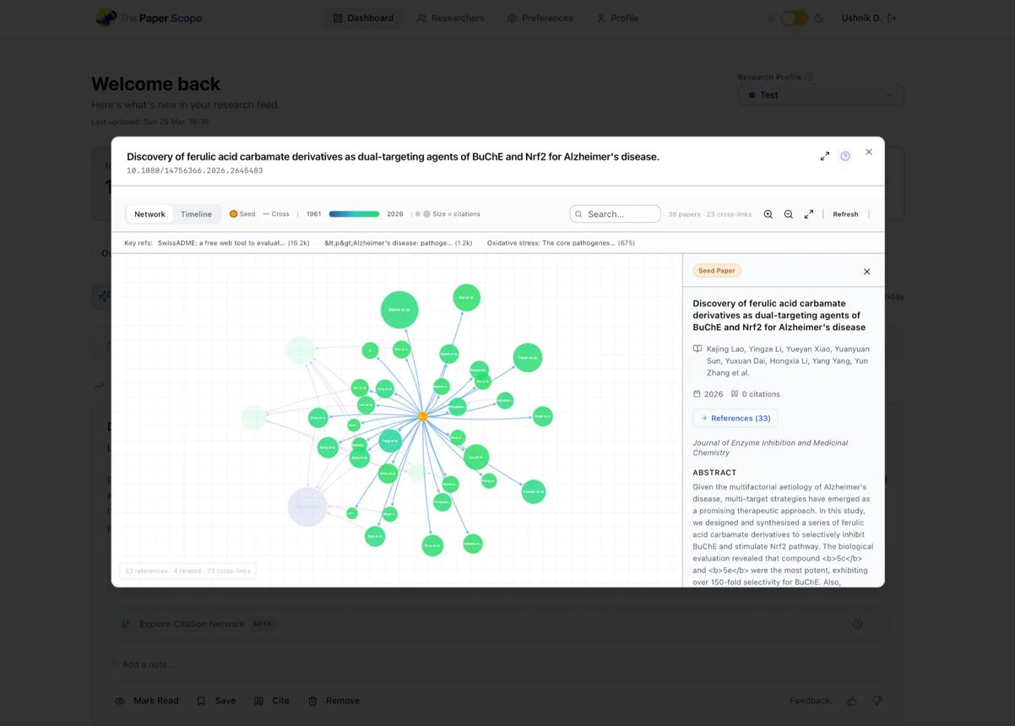
2. Research Paper Recommendation and Discovery System
Retrieve research papers by meaning, discover related topics, rank papers for a query, and recommend relevant papers based on user interests.
My first choice is the AI-Based Cyber Threat Intelligence Retrieval System if you want something less common than a conventional chatbot or search engine. It is a focused project with clear applications for unsupervised learning, supervised ranking, anomaly detection, and neural information retrieval.

